

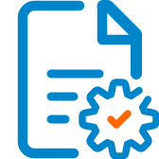

Solution Design Document
Cookie Clicker Game
Authors:
Kalman Horatiu
Ichim Vlad
Manea Robert
Jorza Ionut
Table of Contents
I. Purpose 3
II. Automated process details 5
2 Runtime guide 6
2.1 Architectural structure of the Master Project 6
2.2 Master Project Runtime Details 7
2.3 Cookie Clicker Game 7
2.4 Project(s) workflows 8
2.5 Packages 9
2.6 Architectural structure of the Master Project 9
3 Other Details 10
Future Improvements 10
Other Remarks 10
4 Glossary 11

Purpose

    - Cookie Clicker Game defines a workflow automation process in UiPath Studio. It integrates activities to automate interactions with a website (in this case, cookieclicker.com), sends reports (in this case email), performs browser operations, and parallelizes certain activities to maximize efficiency. It serves as a modular and reusable unit of a broader RPA solution, aimed at demonstrating scalability and handling increased task complexity.
Key Components of the Workflow:
- Input Email Workflow:
  - Purpose: Retrieves the email address
  - Scalability: Can be extended to validate and process email batches.
  - Reusability: Encapsulated as a separate workflow for modularity and future reuse.
- Browser Automation:
  - NApplicationCard: Opens and maximizes a Chrome browser session pointing to www.cookieclicker.com.
  - Purpose: Initializes the browser instance (browserInstance) for subsequent interactions.
  - Robustness: Uses scoped browser instance management, ensuring stateful operations.
- Parallel Execution:
  - Purpose: Executes multiple workflows concurrently:
    - Clicking the "cookie" repeatedly.
    - Buying upgrades.
    - Purchasing store upgrades.
    - Sending an email.
  - Efficiency: Parallel execution reduces total runtime.
  - Reusability: Each operation is modular, allowing easy adaptation for similar use cases.
- Send Email Workflow:
  - Purpose: Sends an email with a report using the extracted email input.
  - Scalability: Supports dynamic recipient handling and extended SMTP configurations. •
Robustness:
The use of scoped browser instances and explicit target elements ensures reliable interaction with the web page, even under dynamic conditions.
Error handling (e.g., ContinueOnError) can be incorporated to mitigate process failures.
• Scalability:
Parallelized workflows efficiently handle increased load or expanded automation tasks.
Modular workflows (e.g., for email handling or browser actions) support scaling the solution to different processes or websites.
• Efficiency:
Parallel execution minimizes runtime, making it suitable for time-sensitive operations.
Activities like Click_Cookie and Buy_Upgrades are offloaded into modular components for targeted optimization.
• Replicability:
The design supports duplication for similar tasks (e.g., automating actions for other websites).
Component reusability simplifies integration into other workflows.
• Reusability:
Separate workflows for email handling and browser actions can be reused across various automation processes.
Modular and independent design makes updating individual workflows straightforward.

Automated process details
Details filled in need to reflect the actual information for the Master Project released for production. The following table will be populated:

Item | Description
Master Project Name | = Cookie Clicker Game
Robot Type | Mix
Orchestrator used? | Yes
Scalable | Yes
UiPath version used | 2023.10.4

Runtime guide

Architectural structure of the Master Project
Display the interaction between components (package / robots, Orchestrator queues, and running order) in a diagram
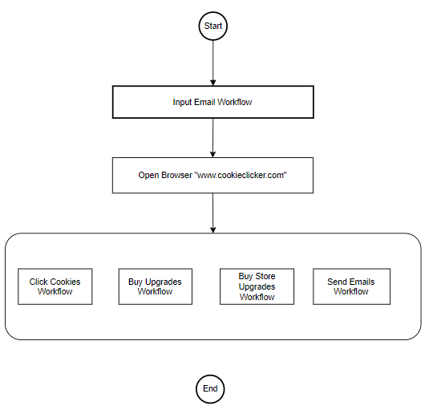

Master Project Runtime Details
Outlines the details of the automated process by filling in the table below.
ITEM NAME | DESCRIPTION  Fill in each bolded section - empty fields are not allowed. If the section does not apply to your automation then mark as n/a.
Production environment details | Running on your personal PC when we decide to press ‘run’
Prerequisites to run | Report is generated every 10 seconds by the machine and it is sent to our personal email (whatever email we insert)
Input Data | 1 valid email address
Expected output | Report of how many cookies we have every 10 seconds
How to start the automated process | The process will be started using the UiPath ‘run’ command
Reporting  (queues reporting, Kibana or another platform) | Number of total cookies and cookies that are generated each second
How is Orchestrator used? | n/a
Password policies  (mention any specific compliance requests) | Email password used.
Stored credentials  (Never use hardcoded credentials in the workflow!) | n/a
List of queues names  (Naming convention: ProcessName_QueueName) | n/a
Schedule Details | Report is sent every 10 seconds
Multiple Resolutions Supported?  (in case of image automation / Citrix and VDI) | n/a
Recommended Resolution | n/a

Cookie Clicker Game
ITEM NAME | DESCRIPTION  Fill in each section - empty fields are not allowed. If the section does not apply to your automation then mark as n/a.
Environment used for development  (name, location, configuration details etc) | Personal Pcs (UiPath Studio)
Environment prerequisites  (OS details, libraries, required apps) | Windows 10, Studio license
Repository for project  (where is the developed project stored) | n/a
Configuration method  (assets, excel file, Json file) | assets
List of reused components | n/a
List of new reusable components | n/a

Add tables for as many projects as you need and fill them in.

Project(s) workflows
Workflows specific to: Specify Project Name from section above
For the workflow files defined below please specify the input and output parameters.
Workflow Name | Description
Main | Invokes the other workflows and is used to run the application
InputEmail | Opens a dialog where the user can insert his email in order to receive the reports
browserActionSpamCookie | Used to continuously press the Cookie in order to generate cookies
browserActionUpgrades | Used to buy upgrades in case an upgrade is available
browserActionStore | Used to buy upgrades from store in case an upgrade is available
browserActionSendEmail | Used to collect number of cookies and then invokes mailFlow workflow
mailFlow | Used to send a report with the number of cookies to the email that we used as input

Packages
Include the list of packages and high-level description for each of them, to explain their purpose
Package Name | Description
n/a | n/a

Architectural structure of the Master Project
Display the interaction between components (package / robots, Orchestrator queues, and running order) in a diagram.

Other Details

Future Improvements
Validate Input Email: Implement a regex-based validation for the email before sending.
Use Logging: Add logging at key steps to help debug and monitor execution.
Optimize Parallel Actions: If the website becomes unresponsive, introduce delays or control flow conditions between actions.
Document Workflow: Include annotations or comments for each activity to make the workflow self-explanatory.

Other Remarks
The program should run well even if we use it for longer periods of time. Feel free to tell us how it did!

Glossary

The main terms used in the Solution Architecture Document are defined below:
Master project - the overall output of the development, containing one or multiple projects that together cover the scope of the robotic process automation. There is a 1 to 1 connection between the Master Project and the Process to be automated (As presented in the PDD).
Project - an UiPath Studio project containing one or multiple workflow files. A project can be converted to a package and run independently, covering a particular scope within the master project. Or multiple projects can be converted into one package depending on the aims and restrictions of the automation. The project is used when defining the development and support phase of the automation.
Package - the output of compiling one or multiple projects. A package can be deployed on the robot machine and be executed by the robot service. Only one package can be executed at a given time by a robot. The package is used when defining the running phase of the automation.
Workflow - a component of the package, the workflow encapsulates a part of the project logic. The workflow can be of type: sequence, flowchart or state machine. A workflow is saved as an .xaml file inside the project folder. A workflow file can be invoked from another workflow and by default there is an initial workflow file that will run when executing the package.
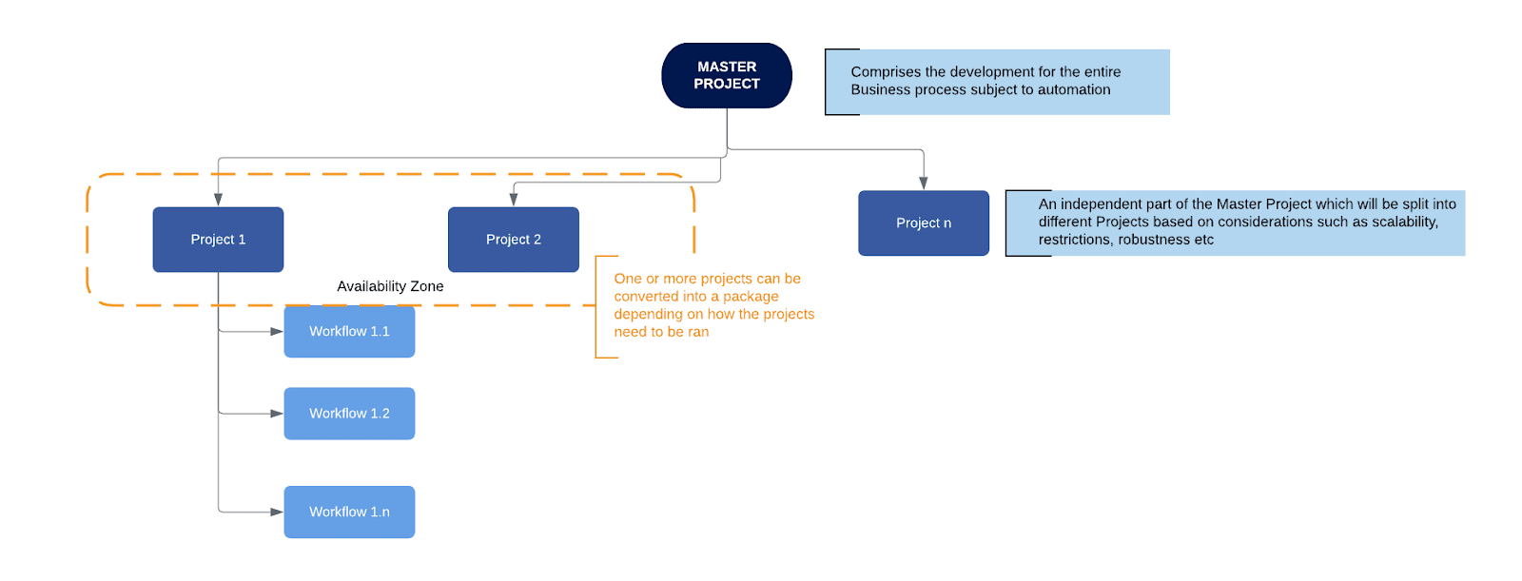
Activity - an action that the robot executes.
Sequence - a workflow where activities are executed one after another, in a sequential order
Flowchart - a workflow where activities are connected by arrows and the logic of the workflow can be easily followed in a visual manner. The flowchart can also be exported as an image from UiPath studio.
State machine - a more advanced way of organizing a workflow, similar to a flowchart.
BOR - Back office robot
FOR – Front office robot
Orchestrator – Enterprise architecture server platform supporting: release management, centralized logging, reporting, auditing and monitoring tools, remote control, centralized scheduling, queue/robot workload management, assets management.

